Adopt-A-Greenway Implementation Plan

The Bear Creek Greenway:

The Bear Creek Greenway (Greenway) is a riparian corridor of land alongside Bear Creek in the Rogue Valley. Its expanse is over 20 miles of paved path, from the Ashland Dog Park to the Dean Creek Road trailhead. The Greenway links many of the towns and cities in the Rogue Valley, such as Ashland, Talent, Phoenix, Medford, and Central Point. The Greenway offers residents many opportunities for a multitude of activities. These include wildlife viewing, with animals like salmon, macroinvertebrates, and birds; biking, running, and walking on the paved trails; and enjoyment of the many parks alongside it. Hawthorne Park, Blue Heron Park, Lynn Newbry Park, and the Ashland Dog Park, as well as many more, are all located along the Greenway. Originally, Bear Creek and the area surrounding it was home to the Shasta and Takelma Native American Tribes, before they were dispossessed by the settlers and miners in search of wealth and farm land. Now, with the help of the Adopt-A-Greenway program, the Bear Breek can be enjoyed and protected by everyone who wants to come be in nature and care for the environment.
The Bear Creek Greenway Guide, first published in 1998, offers a way for Greenway visitors to learn about the area they are visiting in detail. As you walk along the trail, specific points of interest will show up, along with descriptions of what it is and/or its historical significance. Although it was first published in 1998, it has since been revised to be more up to date, and become more accessible to Greenway users in the form of an Application (App).

The Adopt-A-Greenway Program:

The Adopt-A-Greenway Program was created to ensure the continuation and care of the Bear Creek Greenway, including the land and natural habitat around it. It works to involve individuals, families, and organizations by having them adopt a section of the Greenway to maintain. In March 2021, Stream Smart became an official sponsor of the program. They have adopted a large section of the Greenway to be responsible for, from Pine Street to Upton Road. Events and volunteer activities hosted by Stream Smart will be held to clean this specific area.

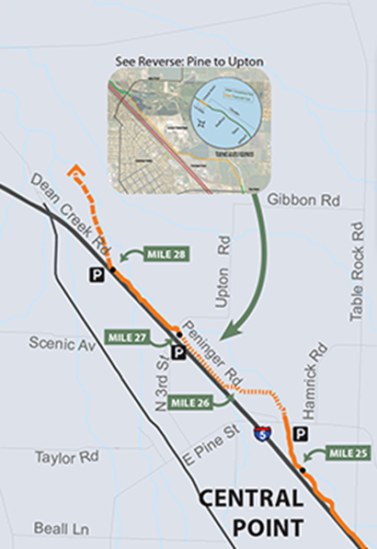

Pine Street Greenway Entrance:

One way to access the Greenway in Central Point is through the Pine Street Greenway entrance. It is located between Pine Street and Peninger Road. The entrance has a gravel parking lot, which leads directly to both a paved trail and an unpaved trail. Along both trails are interpretive signs with information about salmon, wildfire, riparian areas, and pollinator plants, as well as native trees and shrubs. Down the unpaved utility trail, there are a couple of possible salmon observational areas, which offer a place to view and/or monitor the salmon, as well as newly planted Ponderosa Pine trees and re-established willows following the Peninger Fire.
At least once every month, there will be volunteer opportunities and educational activities offered at this location. These will be a chance for individuals and groups in the community to become involved in the restoration and up-keep of the Greenway. These events will be publicized and made known to the community, and specific volunteer groups, with flyers and through the Stream Smart website and Facebook page.

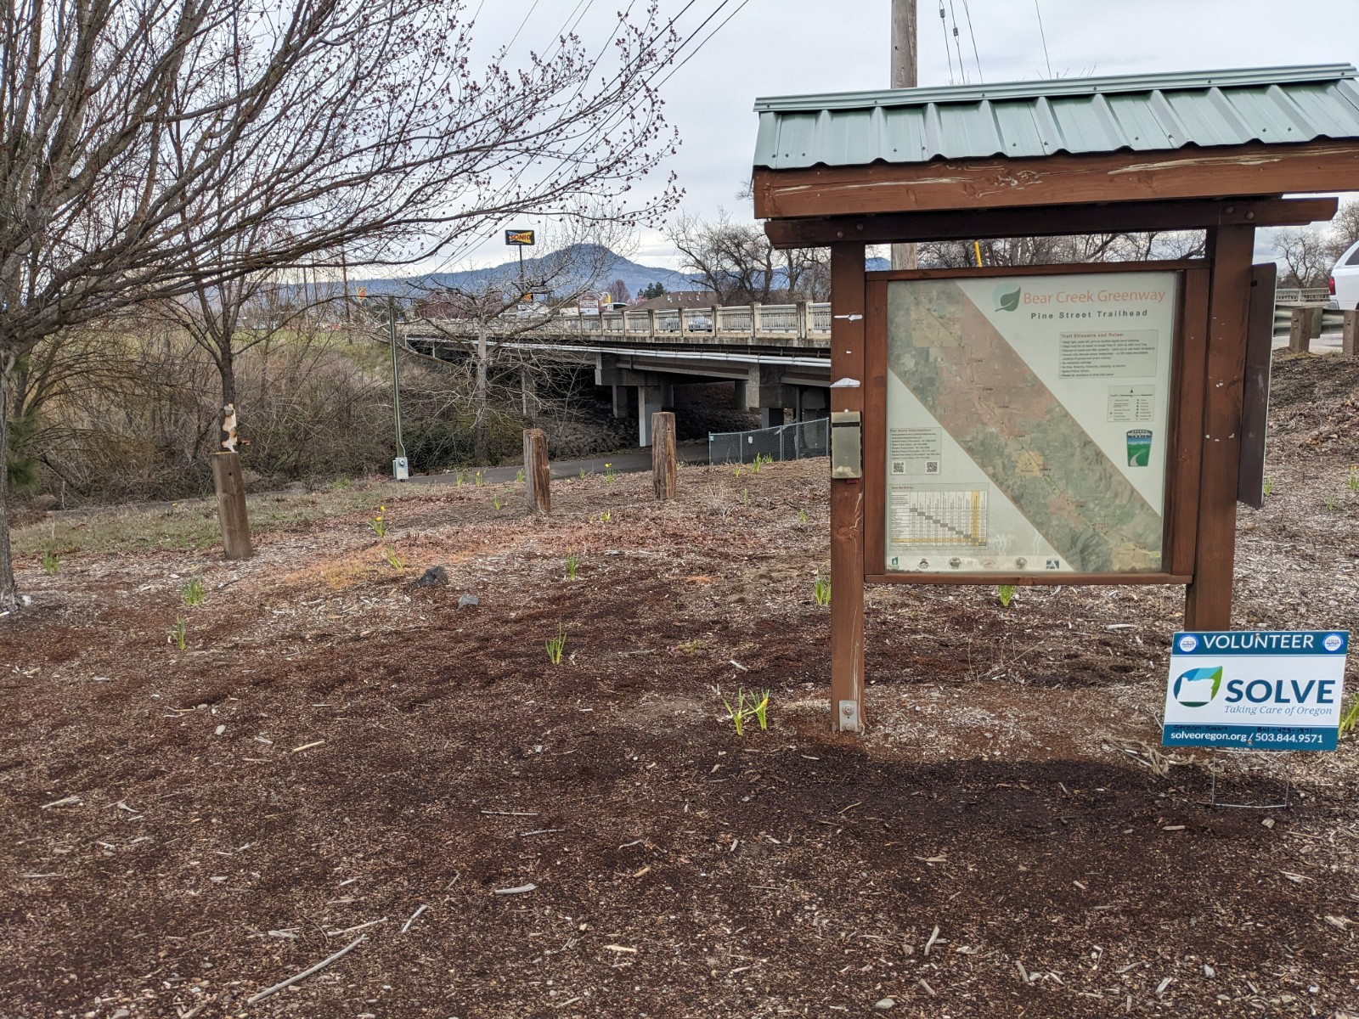

Volunteer Activities:

There is an abundance of activities that could be implemented in this area for volunteers to participate in. Restoring and cleaning the natural environment is very important here, so activities that are centered around this would be very beneficial. Staking willows, planting native trees and shrubs, and caring for the ones already placed (by mulching, weeding, watering, etc.) all help to aid the current environment and wildlife, as well as serve as erosion prevention measures. Installing nesting boxes on some of the more mature trees around the area would support the bird population. Along with that, invasive weed and plant removal, such as the removal of blackberries, and trash pick-up efforts, both in the creek itself and alongside it, are great ways to clean up the area. This also helps to ensure the survival of the native plant and animal species. Viewing some local animal species offers a good way to get people out and learning about wildlife. Salmon watching and macroinvertebrate sampling and identification are both fun and informational activities that the Bear Creek Greenway provides during certain times of the year. In addition to the natural environment, some possible activities could be centered around creating a more user-friendly environment along the Greenway. By replacing an old and dilapidated bench, adding a new informational sign up by the parking lot, and potentially painting some murals on the bridge pedestals with a hired artist, the space can be beautified and become more appealing to visitors.
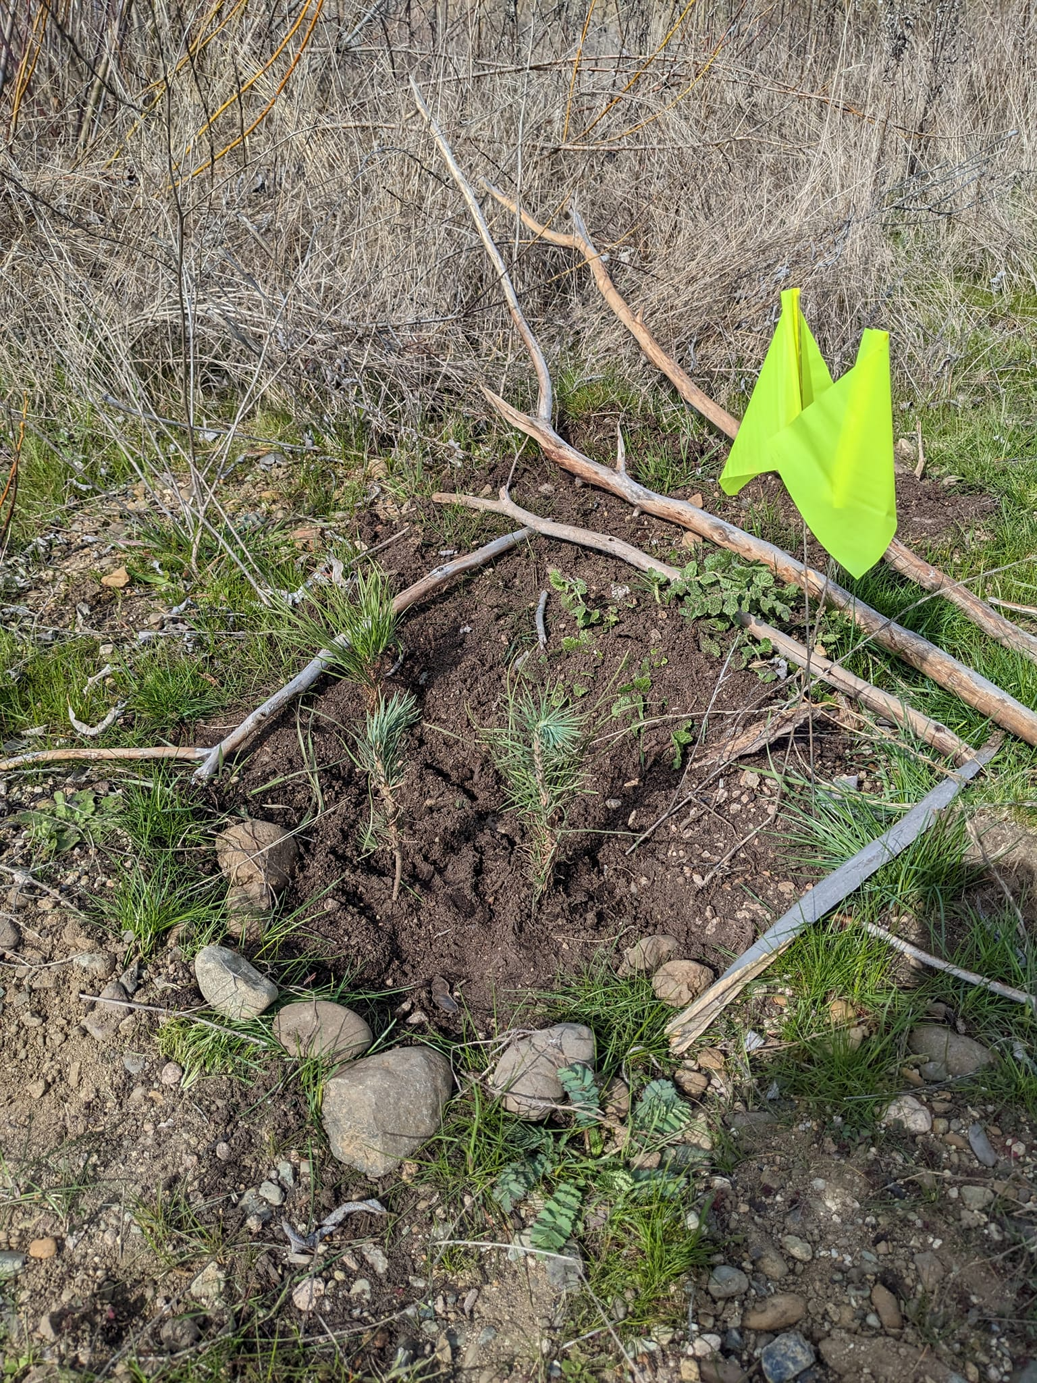

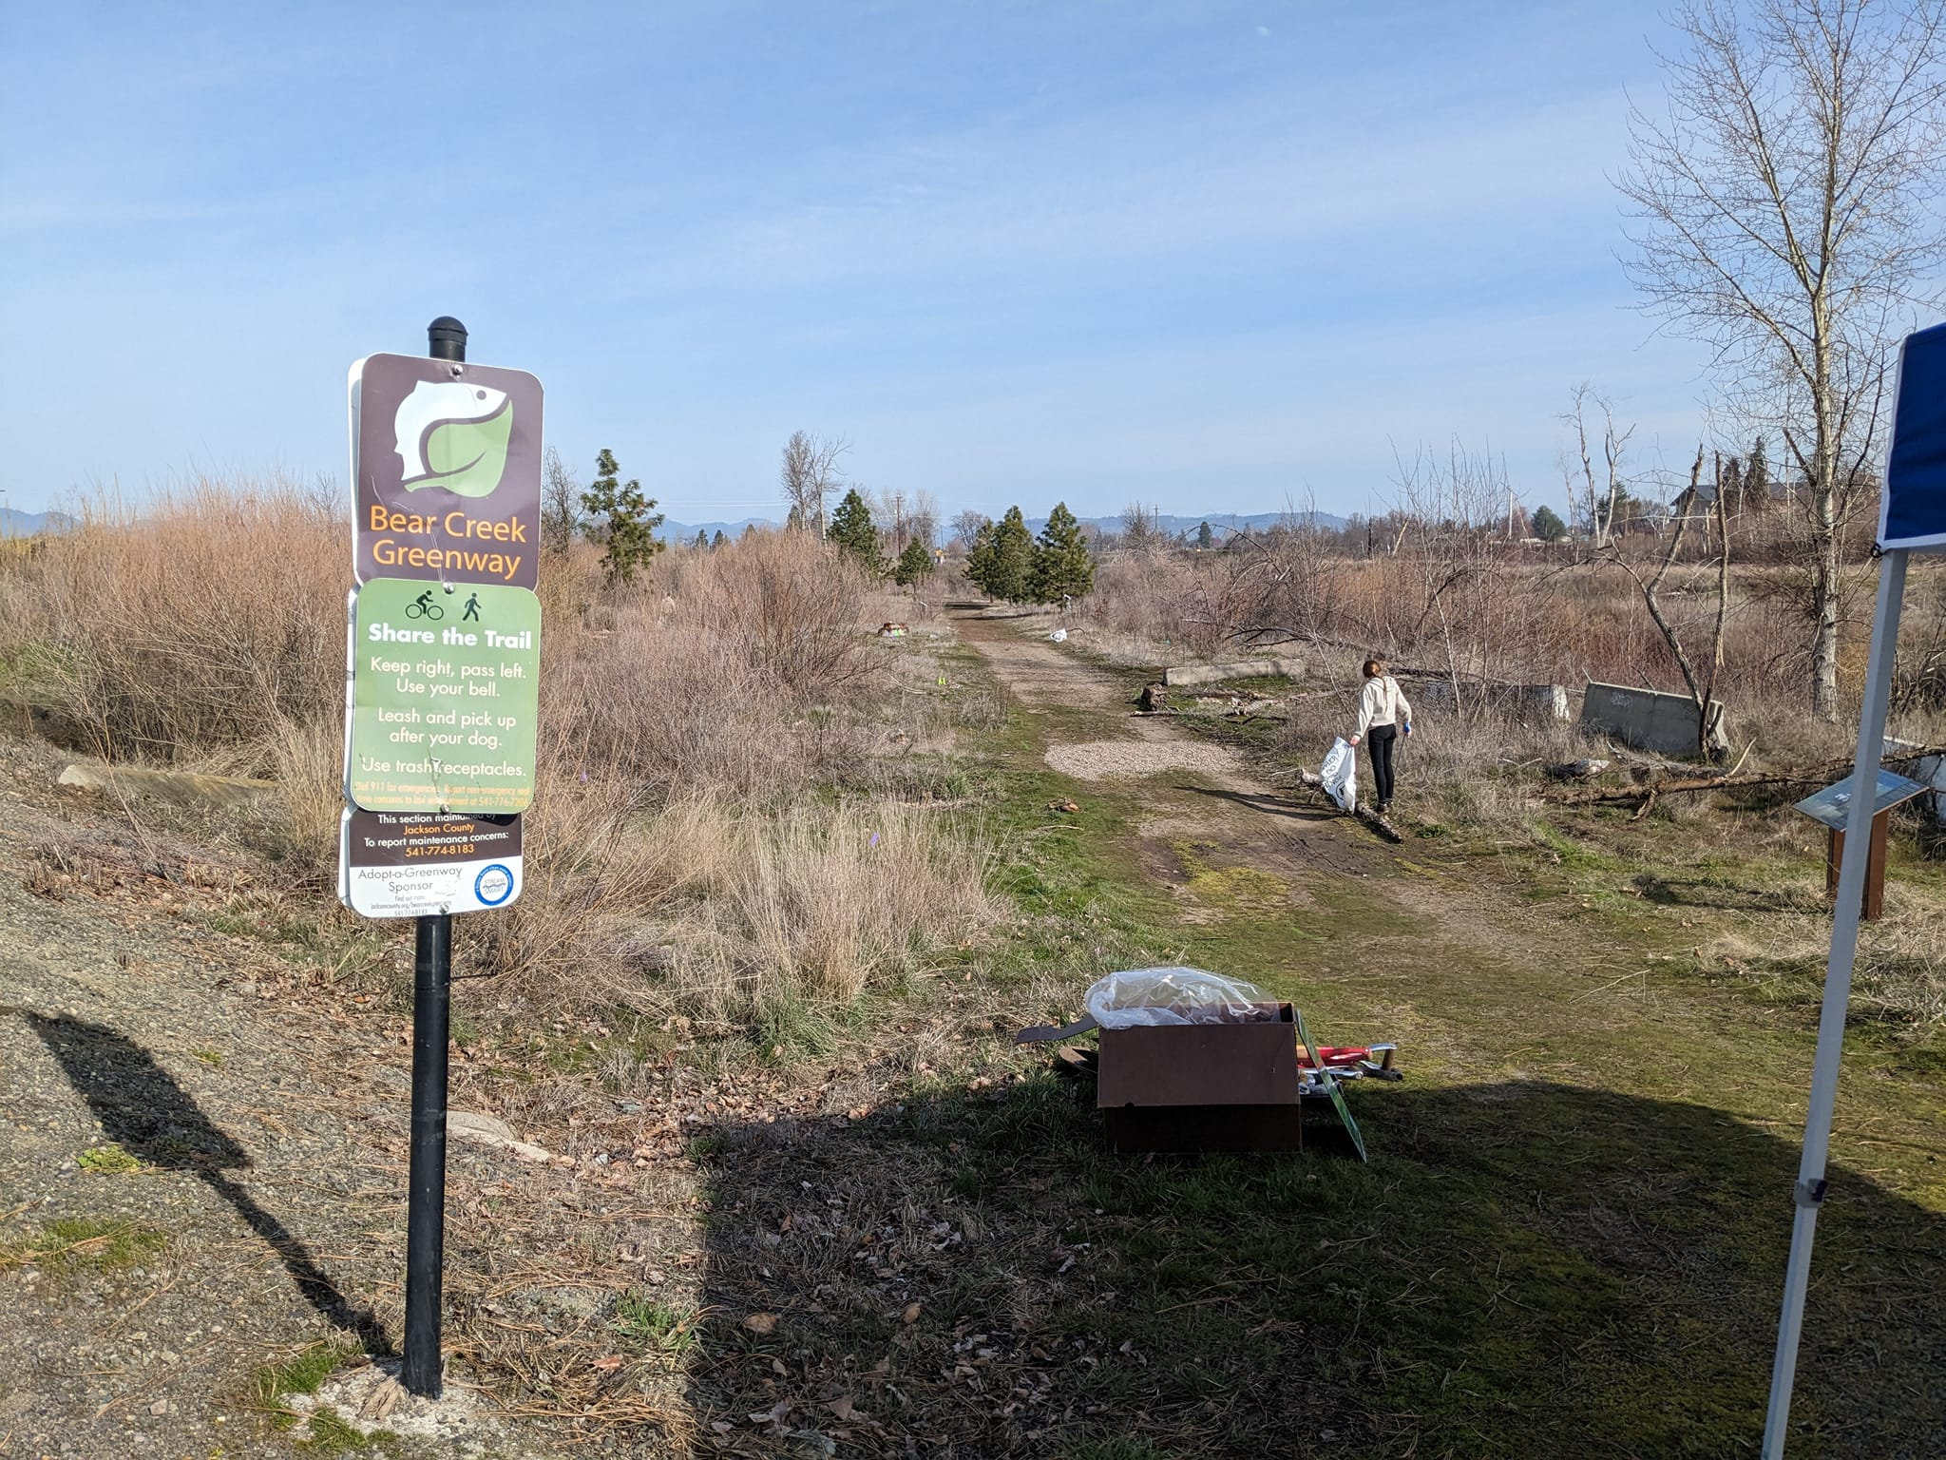

Volunteer Groups:

Potential volunteers to participate in these activities could include many of the local high schools, such as Crater Land Lab and Cascade Christian High School, as well as Rogue Community College (RCC) and Southern Oregon University (SOU). Stream Smart would be the main sponsor for these events, likely with support from the Bear Creek Stewards, Jackson Soil and Water Conservation District, the Rogue River Watershed Council, SOLVE, and others.

Possible Event Locations:

This map illustrates some of the specific locations where events could take place or focus on. Some possibilities are the trees that could be locations for the bird nesting boxes, and what areas need new native trees and shrubs to be planted (for example, down the utility trail and near the entrance/parking lot). It also shows the bench that could be replaced and the bridge that could be a possible location for the murals. These areas are indicated with an asterisk.

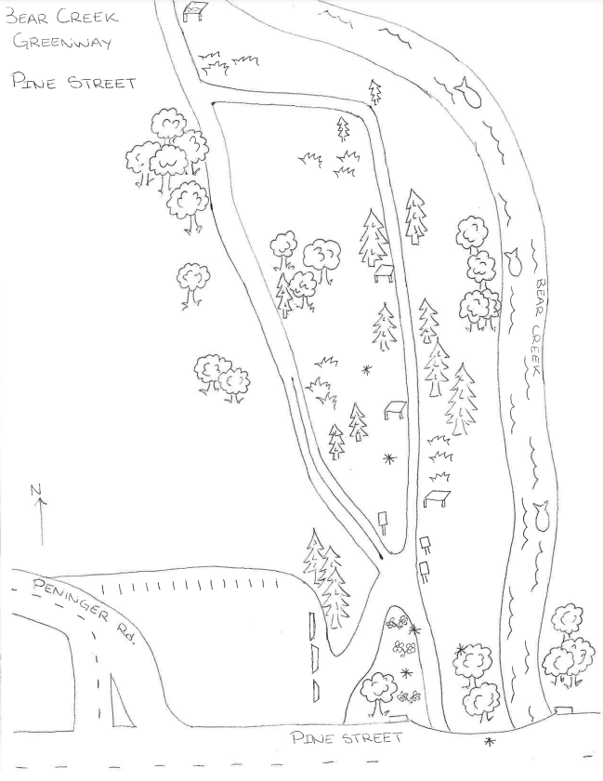

General Timeline For Activities:

Below is a table with a list of months and associated activities. Planting and willow staking are best to do in the colder months (November through March) due to soil accessibility and seasonal precipitation. Salmon viewing and macroinvertebrate collection occurs in the fall as well to get the chance to see the salmon coming up Bear Creek.

Month | Activity
January | Staking, planting (erosion control)
February | Staking, planting (erosion control)
March | Staking, planting (erosion control), and weeding
April | Bear Creek Stewardship Day, plant mulching, and weeding
May | Bridge murals (a possibility)
June | Bridge murals, plant watering
July | Plant watering, trash clean-up
August | Plant watering, trash clean-up
September | Bear Creek Stewardship Day, salmon viewing, macroinvertebrate collection
October | Salmon viewing, macroinvertebrate collection
November | Salmon viewing, planting (if needed)
December | Planting (if needed)

Each season, there will be a quarterly photo monitoring, to update any changes that may have occurred in the environment. Photo monitoring stations will be created prior to the capture of the first set of photos.

Season | Activity
Summer | Photo monitoring (quarterly)
Fall | Photo monitoring (quarterly)
Winter | Photo monitoring (quarterly)
Spring | Photo monitoring (quarterly)

Grants and Funding Sources:

In order to enhance the Greenway to its full potential, grant funding is needed. The grants below could allow all of the necessary supplies to be purchased, as well as make it possible to effectively host volunteer events. In addition to the plants themselves, mulch, soil amendments, and fertilizer are all needed to ensure the survival and success of the plants put in the ground, not to mention potential irrigation systems that may need to be installed. Restoration contractors and practitioners will be needed to maintain the native plants, treat the invasive plants with herbicides, and fix the existing infrastructure. To create an environment friendlier to the everyday Greenway user, additional signs and pedestals could be purchased, along with a new bench. Murals could be painted on the bridge pedestals with a paid artist. Finally, to show thanks to all of the volunteers, these grants could be used in part to purchase appreciation items (volunteer t-shirts and other swag), as well as the supplies used in these events (gardening gloves, tools, snacks, and bottled water).

Grant Name | Grant Source | Reference
Restoration Grants | Oregon Watershed Enhancement Board (OWEB) | https://www.oregon.gov/oweb/grants/Pages/restoration.aspx
Cooperative Endangered Species Conservation Fund | U.S. Department of the Interior  Fish and Wildlife Service | https://www.fws.gov/program/cooperative-endangered-species-conservation-fund
Oregon Parks Foundation Fund | Oregon Community Foundation (OCF) | https://oregoncf.org/grants-and-scholarships/grants/oregon-parks-foundation-fund/
Land and Water Conservation Fund | Oregon Parks and Recreation Department | https://www.oregon.gov/oprd/GRA/Pages/GRA-lwcf.aspx
WaterSMART Environmental Water Resources Projects | Bureau of Reclamation | https://www.usbr.gov/watersmart/ewrp/index.html
Volunteer Appreciation/Swag:

To show appreciation to the many volunteers, as well as to promote more individuals into coming out and helping, swag can be given out at the volunteer events. T-shirts, patches, hats, and water bottles with the Stream Smart logo are great ways to get people excited about volunteering. The prizes could become larger, based on how many events someone comes out to volunteer for. Small one-time prizes could include badges and stickers, while larger prizes would be t-shirts, hats, and water bottles.

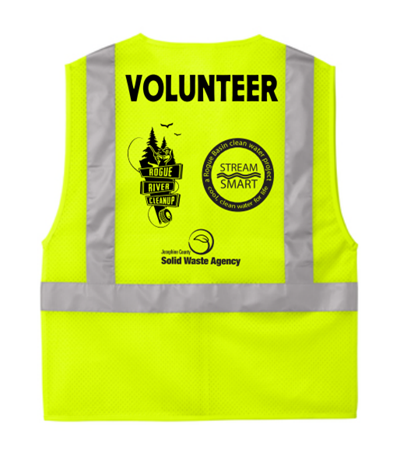

References:

Bear Creek Greenway Foundation. History. http://bearcreekgreenway.com/.

Jackson County Parks. Bear Creek Greenway. https://jacksoncountyor.org/parks.

Stream Smart: A Rogue Basin Clean Water Project. Bear Creek Greenway Guide and
Application (App). https://www.stream-smart.com/.

