PRESS RELEASE
Rogue Valley Council of Governments • • • • Natural Resources Department

CREEK SAFETY WATCH

Bear Creek Watershed – Jackson County

July 13th, 2022

Important Note: This information is for select creeks in the Bear Creek Basin only –
IT DOES NOT COVER ALL CREEKS IN JACKSON COUNTY OR ALL CREEKS IN THE BEAR CREEK WATERSHED. If you have questions about a specific creek, please call RVCOG (see contact information below).

Routine water quality testing results indicate that the following creeks have exceeded state bacteria standards for contact recreation (swimming, wading, etc.). Residents are asked to use caution when in contact with any waterways and especially to avoid ingestion (which may cause illness) and contact with open wounds (which may cause infection). Very young children should be fully supervised when playing in the water to avoid swallowing the water. It is important to note that contact with any water body – creeks, rivers, lakes, or swimming pools – carries some level of risk.

Possible causes of high levels of bacteria in the creeks include: 1) pet waste, 2) livestock waste, 3) wild animals, 4) leaking septic systems, 5) illegal dumping from portable toilets or RVs, or
6) any other activity that results in the discharge of fecal matter directly into creeks or through storm drains.

Citizens are asked to notify the appropriate agency of any concerns. Failing septic systems and other pollutants discharged into streams should be reported to the Department of Environmental Quality. Complaints can be reported to the complaint hotline at 1-888-997-7888 or online at http://www.deq.state.or.us/complaints/rep.htm. If you are unsure of whom to call or have questions regarding which creeks are tested, please call Greg Stabach (541-423-1370) or Amie Siedlecki (541-423-1371) from the Rogue Valley Council of Governments, or visit http://rvcog.org/what-we-do/natural-resources/.

What you can do: 1) pick up after your pets, 2) keep manure, kitty litter, and other waste material away from creeks and storm drains, 3) have your septic system inspected and repaired if failing, and 4) put toddlers in swim diapers.

More information is available from the Rogue Valley Council of Governments, Natural Resources Department (http://rvcog.org/what-we-do/natural-resources/), the Stream Smart Monitoring Water Quality in the Rogue Basin webpage (http://www.stream-smart.com/monitoring-water-quality-in-the-rogue-basin/), the Oregon Department of Human Services (www.egov.oregon.gov/DHS), and the Environmental Protection Agency (http://www.epa.gov/waterscience/criteria/humanhealth/).

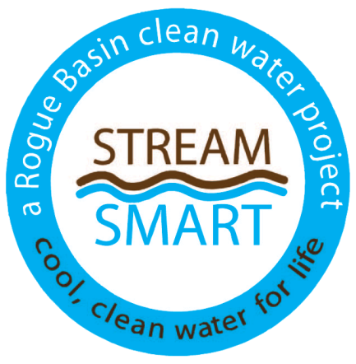
The following creeks have exceeded state bacteria standards for contact recreation (swimming, wading etc.).

Walker Creek at Belle Fiore Lane (Ashland)
Ashland Creek below the wastewater treatment plant (Ashland)
Bear Creek at Eagle Mill Road (Ashland)
Bear Creek at Suncrest Road (Talent)
Bear Creek at 9th Street (Medford)
Jackson Creek at Dean Creek Road (Central Point)

