RVCOG Storm Drain Monitoring Program:

2013-2018 Report

Draft

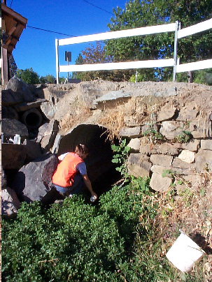

December 2018
Rogue Valley Council of Governments
Natural Resources Department
155 North First Street
Central Point, Oregon 97502

www.rvcog.org

Abstract

This report summarizes data collected for the Storm Drain Monitoring Program for five complete water years, August 2013 through May 2018. This report contains:

- Background information on the monitoring program and existing water quality standards,
- Monitoring methods,
- Storm drain results, and
- General recommendations based on site data.

Continued characterization of the effluent discharged from storm drains will help jurisdictions identify and ultimately eliminate pollutant sources. Additionally, a baseline of storm drain water quality allows jurisdictions to evaluate stormwater program effectiveness using data collected before implementation of stormwater management programs.

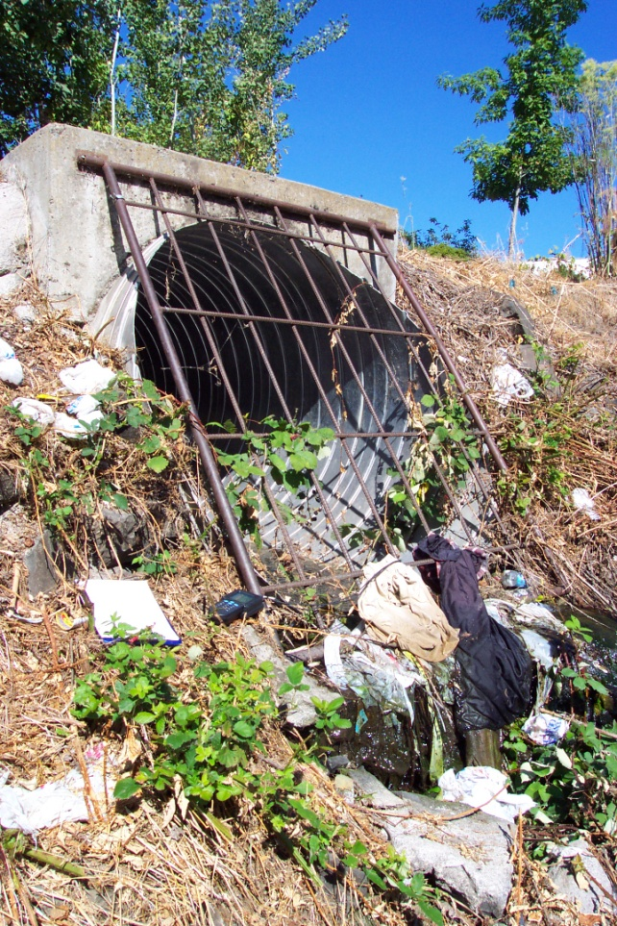
Storm drain located in Medford that discharges directly into Bear Creek.

Table of Contents

Abstract i

Table of Contents ii

Section 1.0: Introduction and Overview 1

  - Introduction 1
  - Monitoring Program Overview 1
  - Existing Water Quality Standards 2
  - Program Changes 4
    - Site Changes 4
    - Procedural Changes 4
  - Acknowledgements 5

Section 2.0: Methods 6

Section 3.0: Monitoring Results and Discussion 7

3.1 Data Summary 7
3.2 Exceedances 7
3.3 Sample Type (Dry, First Flush, and Wet) 8

Section 4.0: Program Recommendations 11

Section 5.0: References 12

Appendices:

Appendix A: Monitoring Locations and Descriptions 14

Appendix B: Data Summary by Monitoring Run 17

Section 1.0: Introduction and Overview

  - Introduction

Working on behalf of the designated management agencies (DMAs) within the Bear Creek Watershed, the Rogue Valley Council of Governments (RVCOG) established the Storm Drain Monitoring Program in 1996. The program was designed to meet the requirements of the Implementation and Compliance Schedule set forth by the Oregon Department of Environmental Quality (ODEQ) in 1992. The goal of the monitoring program is to characterize the nature of the effluent discharging from storm drains into Bear Creek and its tributaries, which may contribute to exceedances of water quality standards. In addition, monitoring efforts provide a baseline to evaluate the effectiveness of implemented storm water management plans.

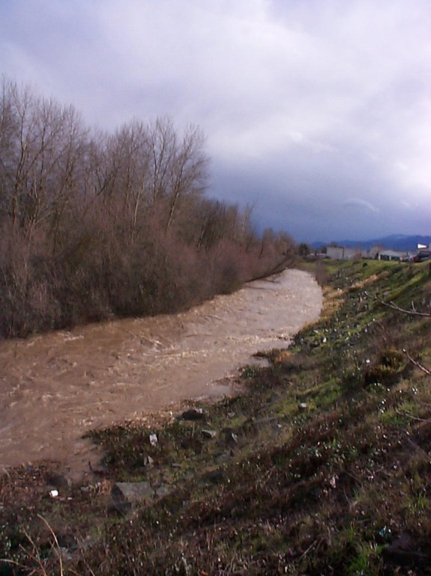
Turbid Flow in Bear Creek

  - Monitoring Program Overview

All sites are sampled three times a year. The number of samples collected varies based on accessibility, amount of discharge from the storm drain (if any), and duplicate sampling. The first samples are taken during “dry weather flows,” before the first rains of the season, generally in late July or early August. The second set of samples, “first flush samples,” are collected at the first storm event of the season. This event creates surface runoff and ample flow in the storm drain system, and usually occurs in October or November. The third samples, “wet weather,” are taken at least 60 days after the first flush collection, during a high flow event.
Stormdrain monitoring site: Ashland wetland with stormdrain input

A total of sixteen sites are sampled. The number of sites per municipality is summarized below: City of Ashland (3), City of Talent (2), City of Phoenix (2), City of Medford (4), City of Central Point (3), and the City of Jacksonville (2).

  - Existing Water Quality Standards

Bear Creek is listed as a water quality limited stream on the 303(d) list by ODEQ. This listing requires the state to identify specific pollutants (parameters) that are a problem for Bear Creek. Once pollutants are identified, the state must then develop Total Maximum Daily Loads (TMDLs). A TMDL defines the theoretical amount of a certain pollutant that can be present in a waterbody without causing impairment to the designated beneficial uses. Beneficial uses are the uses of water necessary for the survival and well-being of man, plants, and wildlife (Table 1.1).

Table 1-1: Beneficial Uses in Bear Creek

There are 13 Beneficial Uses assigned to the Bear Creek mainstem in Oregon Administrative Rules (OAR) Section 340-041-0271. Those marked with a check are identified by ODEQ as being impaired.
Beneficial Use | Impaired | Beneficial Use | Impaired
Industrial water supply |  | Livestock watering
Fish and aquatic life |  | Wildlife and hunting
Fishing |  | Water contact recreation
Anadromous fish passage |  | Salmonid fish rearing
Irrigation |  | Salmonid fish spawning
Aesthetic quality |  | Municipal sources
Boating

Bear Creek was placed on the 303(d) list by ODEQ in November 1987. TMDLs were developed in 1992 for dissolved oxygen (DO), ammonia, biological oxygen demand (BOD), and total phosphorus (TP). A second TMDL for bacteria, temperature, and sedimentation (Reeder Reservoir – Ashland only) was approved by EPA in 2007. Other applicable standards for water quality in Oregon are outlined in OAR 340, and are enforced by ODEQ. Standards used for comparison of monitoring results are based on TMDL loadings, fish spawning and rearing needs, and other considerations. Tables 1-2 and 1-3 summarize the current standards.

Storm water discharge is not regulated specifically, although the standards are used as a comparison due to their potential influence on water quality in Bear Creek. In addition, the data is evaluated and used by the Bear Creek National Pollutant Discharge Elimination System (NPDES) Phase II Stormwater Programs currently underway in the region for Medford, Ashland, Central Point, Phoenix, Talent, and Jackson County. Rogue Valley Sewer Services (RVSS) implements the Phase II Program for Central Point, Phoenix, Talent, and Jackson County.

Table 1-2: Water Quality Standards Based on the 1992 TMDL Requirements
Parameter  Covered Under 1992 TMDL | Low Flow  (summer season)  May 1 – Oct 31 | High Flow  (winter season)  Nov 1 – April 30
Ammonia as Nitrogen | 0.25 mg/l | 1.0 mg/l
Biological Oxygen Demand | 3.0 mg/l | 2.5 mg/l
Dissolved Oxygen | 8.0 mg/l or 90% saturated³ | 11 mg/l or 90% saturated³
Total Phosphorus | Water quality standard based on DEQ interim targets of 0.08 mg/L total phosphate as phosphorus | -

Table 1-3: Current Water Quality Standards

Parameter | Low Flow  (summer season)  May 1 – Oct 31 | High Flow  (winter Season)  Nov 1 – April 30
Fecal Coliform⁴  E. coli | A) A 30-day log mean of 126 E. coli organisms per 100 milliliters, based on a minimum of five samples;  (B) No single sample may exceed 406 E. coli organisms per 100 milliliters. | Same values
Temperature* | 64o F¹
Flow Modification | No numerical standard | No numerical standard
^{1.} 7-day consecutive average high temperature. Temperature standard for salmonid fish rearing is from June 1 – September 30.
^{3.} Dissolved Oxygen Standard, May 1 – October 31 (summer), November 1 – April 30 (winter).
^{4.} Fecal coliform standard was changed to E. coli in 1996.
*Currently, the temperature standard is 13.0° C (55.4 F) for streams identified as having salmon and steelhead spawning use (October 15- May 15), 18.0° C (64.4 F) for streams identified as having salmon and trout rearing and migration (May 16- October 14), and 16.0° (60.8 F) for streams identified as Core Cold Water Habitat. All of the standards can be superseded under section 8 of OAR-340-41.

Additional parameters not covered by this table include turbidity, total suspended solids (TSS), and pH. According to OAR 340-041-0036 and 340-041-0275, the following standards apply:
- No more than a ten percent (10%) cumulative increase in natural stream turbidities shall be allowed, as measured relative to a control point immediately upstream of the turbidity-causing activity.
- pH values must range from 6.5 to 8.5.

1.4 Program Changes

The program incorporates an adaptive management strategy meaning that based on previous results and outcomes, RVCOG and the DMAs will evaluate the program and determine actions to be taken to increase program effectiveness. In this manner, changes are implemented to build a storm drain monitoring program that will more effectively
1) assist the DMAs in meeting their Implementation and Compliance Schedule,
2) describe storm drain water quality, 3) guide management efforts, and 4) support the NPDES Phase II program.

1.4.1 Site Changes

Representatives from each jurisdiction have been consulted in order to identify any necessary and appropriate changes in storm drain sampling sites. The following table lists the three new sites as of August 2013, all located in Ashland.

Table 1.4: 2013 Storm Drain Site Changes
DMA | New Site
Ashland | Wightman St. north of the railroad tracks (ditch)
Ashland | Mountain Ave. adjacent to Bear Creek (PVC pipe)
Ashland | Nevada St. bridge (culvert)

Site location photos are included in Appendix A.

1.4.2 Procedural Changes

No changes were made during the reporting period. The information was kept in the report for consistency and reference.

E. coli Testing

RVCOG switched from fecal coliform testing to E. coli testing in April 2001. This change was implemented in order to comply with new ODEQ standards. DMAs provided additional funding to make this transition possible.

Total Phosphorus Accuracy

RVCOG staff underwent training at the ODEQ laboratory in Portland to improve the accuracy of the total phosphorus analysis.

Instrumentation

An YSI Pro30 temperature and conductivity field meter was purchased in 2018 for onsite analysis of temperature and conductivity.

1.5 Acknowledgements

The RVCOG Storm Drain Monitoring Program is supported by Jackson County and the cities of Ashland, Talent, Phoenix, Medford, Jacksonville, and Central Point. RVCOG lab analyses are performed at the Medford Regional Water Reclamation Facility. RVCOG would like to extend a special thank you to the local jurisdictions and participants in the program. The support of our many partners contributes significantly to the overall program success.

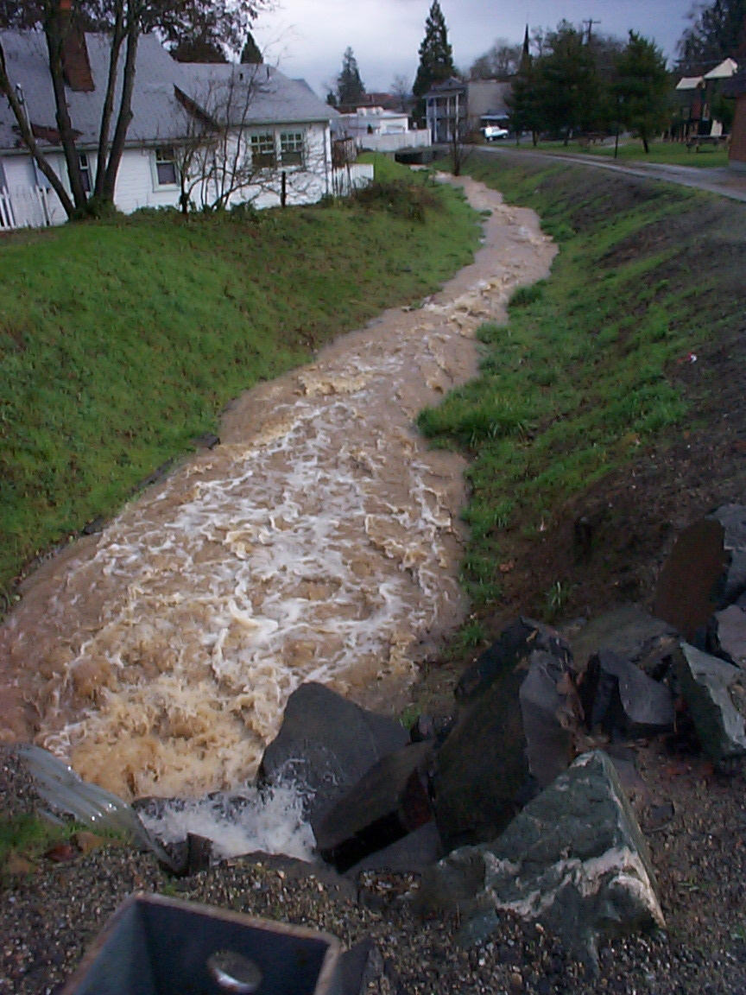
First flush stormwater flows.

Section 2.0: Methods

Storm drain sampling consists of grab or bucketed samples collected at each site. Samples are analyzed for temperature, conductivity, turbidity, pH, E. coli, BOD, and total phosphorus. Water samples from each site are transported by RVCOG to the lab under agreement with the Medford Regional Wastewater Reclamation Facility and analyzed by RVCOG personnel. All samples collected by RVCOG are kept cool in transport, refrigerated, and/or preserved per Quality Assurance/Quality Control (QA/QC) recommendations.

RVCOG equipment, sampling, and testing procedures are all ODEQ approved. In addition, the program operates under a QA/QC Plan overseen by ODEQ and the program results meet or exceed ODEQ requirements. The QA/AC protocol includes internal measures (duplicate samples and external measures (bi-monthly splits with ODEQ)).

Parameters Monitored:

- Water temperature and conductivity was recorded during each site visit using a calibrated YSI Pro30 field meter.
- Turbidity was measured using a calibrated turbidity meter (Hach 2100P Turbidimeter).
- pH was measured using a calibrated Hach pH meter.
- E. coli was measured using the IDEXX Quanti-tray/2000 method.
- BOD was measured using the 5-day BOD test (Standard methods, 1995 ed. Method 5210 B.)
- Total phosphorus was measured using the modified ascorbic acid method and a Spectronic Instruments Spectronic 20D+ Model Spectrophotometer (Method 365.1, Storet 70507).

Section 3.0: Monitoring Results and Discussion

3.1 Data Summary

Exceedances were calculated for each sample type (dry weather, first flush, and wet weather) for E. coli, total phosphorus, and BOD (Table 3.1). TMDL standards and OAR standards were used to calculate the exceedances.

Exceedance data is followed by charts displaying the median values of parameters from a selected site within each jurisdiction (refer to Section 3.3). One site from each jurisdiction, for a total of six sites, were evaluated to compare the input of selected parameters throughout the watershed.

Data collected, visual surveys, photographic documentation, and statistical analysis have all been used to make recommendations and document program results characterizing stormwater quality. The recommendations will assist the DMAs in maintaining their commitment to protect public health, improve local waterways, and comply with the TMDL and the NDPES Phase II Stormwater Program.

3.2 Exceedances

Wet weather water quality had the highest percent exceedance of BOD and phosphorus (Table 3.1; 87% and 98%, respectively), but first flush water quality had the highest percent exceedance of bacteria (70%). Phosphorus levels measured during dry weather, first flush, and wet weather sample types were all similar (95%, 96%, and 98%, respectively). Overall, high levels of phosphorus occurred at all sites, and at least half of the total samples taken exceeded the 406 MPN standard for E. coli.

Water quality generally decreases due to a variety of influences, including domestic usage (lawn watering, fertilization, and pet waste), recreational useage, agricultural influences (irrigation canals), leaking septic systems, wildlife and feral animals, construction, and many other factors.

Table 3.1: Percent Exceedance by Sample Type for BOD, E. coli, and Phosphorus

BOD Exceedance: 2013 – 2018
Sample Type | % Exceedance at Standard* | Count
Dry Weather | 53% | 25/47
First Flush | 65% | 44/68
Wet Weather | 87% | 62/71
*Applied 2.5 mg/l for Winter Exceedance (November 1 – April 30)
*Applied 3.0 mg/l for Summer Exceedance (May 1 – October 31)
Bacteria (E. coli) Exceedance: 2013 – 2018
Sample Type | E. coli % Exceedance at Standard (406 MPN) | Count
Dry Weather | 51% | 20/39
First Flush | 70% | 48/69
Wet Weather | 66% | 47/71
Phosphorus Exceedance: 2013 – 2018
Sample Type | Phosphorus % Exceedance at Standard (0.08 mg/L) | Count
Dry Weather | 95% | 37/39
First Flush | 96% | 66/69
Wet Weather | 98% | 56/57

3.3 Sample Type (Dry Weather, First Flush, and Wet Weather)

One site from each jurisdiction was selected to compare median levels of turbidity, E. coli, phosphorus, and BOD for each sample type. These charts provide information on how sites fluctuate between each sample type and how sites vary. The red lines on the charts indicate the location of the water quality standard.
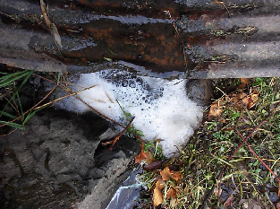

Turbidity

Turbidity levels were generally higher during the first flush and wet weather sampling events, with lower levels during dry weather sampling event (see Chart 3.1). The data from this report will be reevaluated to ensure that there are no data entry errors, and any discrepancies will be rectified before finalizing the report. Median turbidity levels exceeded the OWEB standard of 50 ntus at six sites during the wet weather sampling event: Talent: Wal-Mart parking lot by creek bank (SD 5), Medford: 10th (9th) St. on west bank (SD 9), Medford: Riverside and Walnut St. (SD 10), CP: Mingus Creek near Expo Ponds (SD 14), CP: Griffin Creek at Hwy. 99 (SD 16), and Ashland: Nevada St. bridge (SD 19). It’s important to note that SD 14 exceeded median turbidity levels during the first flush sampling event, as well.

Chart 3.1: Median Turbidity Levels by Sample Type for Selected Sites

E. coli

During the dry weather sampling, the median E. coli levels for seven of the sixteen sites exceeded the ODEQ standard of 406 MPN. The first flush sampling revealed that median E. coli levels for thirteen sites exceeded the standard, and the wet weather sampling showed that median E. coli levels for ten of the sites exceeded the standard.

Chart 3.2: Median E. coli Levels by Sample Type for Selected Sites

Phosphorus

Median phosphorus levels for all sites, regardless of sample type (dry weather, first flush, and wet weather), tested over the state standard of 0.08 mg/L.

Chart 3.3: Median Phosphorus Levels by Sample Type for Selected Sites

BOD

During the dry weather sampling, the median BOD levels for seven of the sixteen sites exceeded the summer standard of 3.0 mg/l. The first flush and wet weather sampling events both revealed that median BOD levels for fifteen sites exceeded the winter standard of 2.5 mg/l.

Chart 3.4: Median BOD Levels by Sample Type for Selected Sites

*2.5 mg/l line represents the winter standard (November 1 – April 30)
*3.0 mg/l line represents the summer standard (May 1 – October 31)

Section 4.0: Program Recommendations

- Storm Drain Data:
Additional funding is needed to incorporate the data into regular reporting and analysis. Currently, data is reported annually but an entire data analysis would allow for a better understanding of storm drain influence on water quality. Longer reports are compiled every five years, but a statistical analysis similar to the one performed by Cadmus for the TMDL should be investigated to evaluate for program effectiveness.

- Additional Source Monitoring:
RVCOG recommends that the DMAs identify and perform additional monitoring (or other field work) in their communities to help them identify and remove or reduce pollutant input via storm drains.

- Illicit Discharge Detection (IDD) and Monitoring Program:
The IDD monitoring program would include the following: visually inspecting all storm drain outfalls twice a year, periodically testing the drainage water quality including bacteria, mapping and identifying all outfalls, and establishing a tracking procedure for illicit discharge.

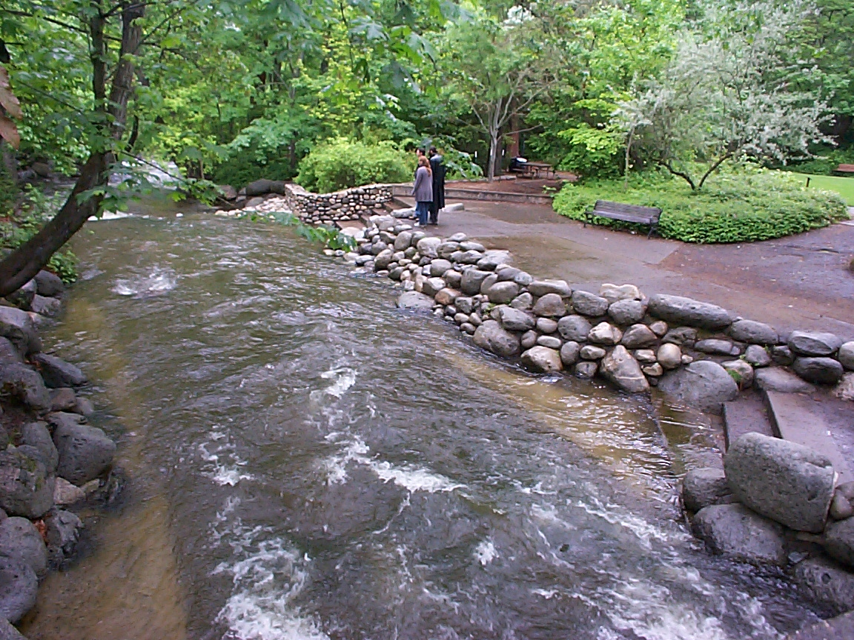
Ashland Creek Spring Flows

Section 5.0: References

CSU. 2001. Data accessed from the web
(http://www.grc.nasa.gov/WWW/K-12/fenlewis/Waterquality.html). Cuyahoga River Water Quality Monitoring Program, Cleveland State University. Cleveland, OH.

EPA. 2002. Data accessed from the web (www.epa.gov).
Environmental Protection Agency. Washington, D.C.

Hem, John. 1987.
Study and Interpretation of the Chemical Characteristics of Natural Water. United States Geological Survey. Washington. D.C.

Helsel, D.R., and Hirsch, R.M. 1992.
Statistical Methods in Water Resources. Elsevier Publishing,. New York.

KWWP. 2001. Data accessed from the web
(http://water.nr.state.ky.us/ww/ramp/rmdo2.htm.) Kentucky Water Watch Project. Frankfurt, KY.

Mitchell, Mark., and Stapp, William. 1990.
Field Manual for Water Quality Monitoring: An Environmental Education Program for Schools. Thomson-Shore Printers. Dexter, Michigan.

DEQ. 2002.
Oregon’s Draft 2002 303(d) List. Oregon Department of Environmental Quality.

DEQ. 2001.
Oregon Water Quality Index Summary Report Water Years 1992-2001. Curtis Cude, Oregon Department of Environmental Quality.

Olson, Lori. 2000.
Summary of Bear Creek Water Quality Data. Southern Oregon University. Ashland, OR.

OWEB. 1999.
Oregon Watershed Assessment Manual. Oregon Watershed Enhancement Board. Salem, OR.

RVCOG, 1998.
Bear Creek Basin Non-Point Source Pollution Water Quality Testing Program and TMDL Sampling Project: Quality Control-Quality Assurance Plan. Central Point, OR.
RVCOG, 2001.
Quinby, Caitlin, and Stabach, Greg. Data Inventory and Analysis Procedures Manual. RVCOG. Central Point, OR.

Sawyer, C. N. and P. L. McCarty. 1967.
Chemistry for Sanitary Engineers. 2nd Ed. McGraw-hill Book Co. N.Y.

Appendix A: Monitoring Locations and Descriptions

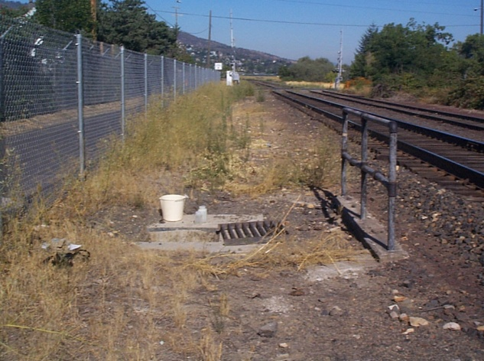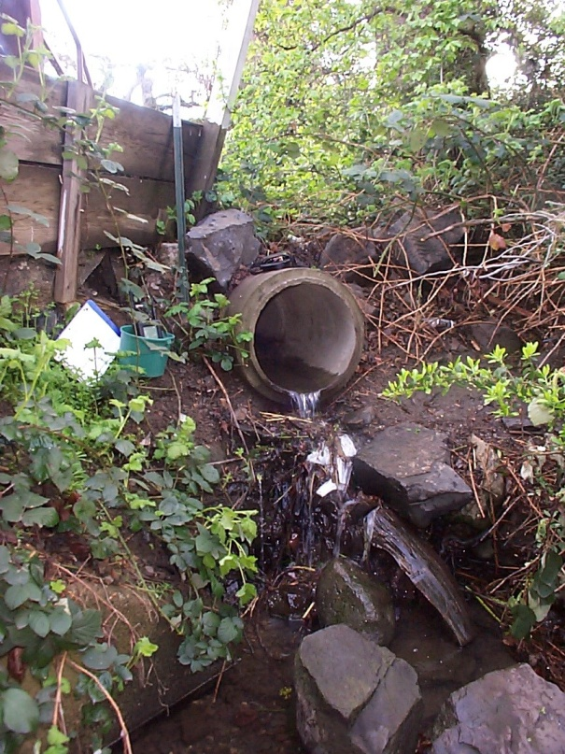
Mountain Ave., Ashland Wagner Creek at Talent Avenue, Talent
Storm Drain

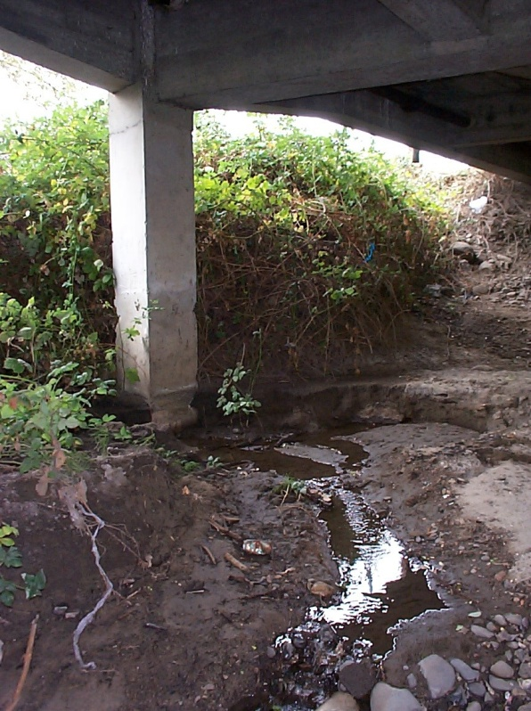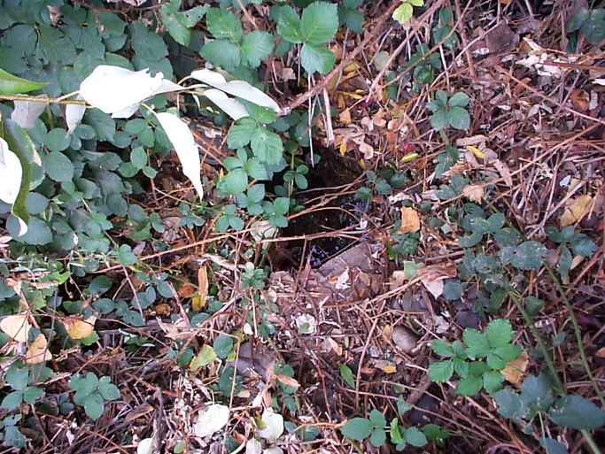
Storm Drain
Under bridge near Wal-Mart, Talent Highway 99 at Oak Street, Phoenix

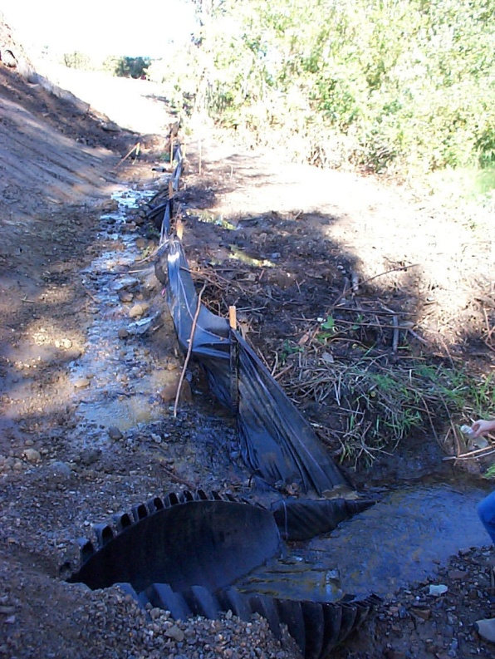
Storm Drain
Highway 99 at 4th Street, Phoenix

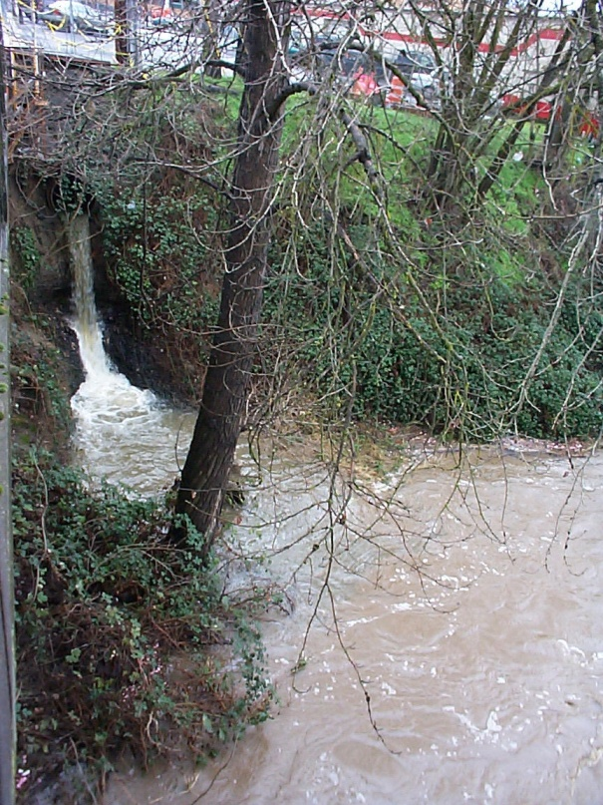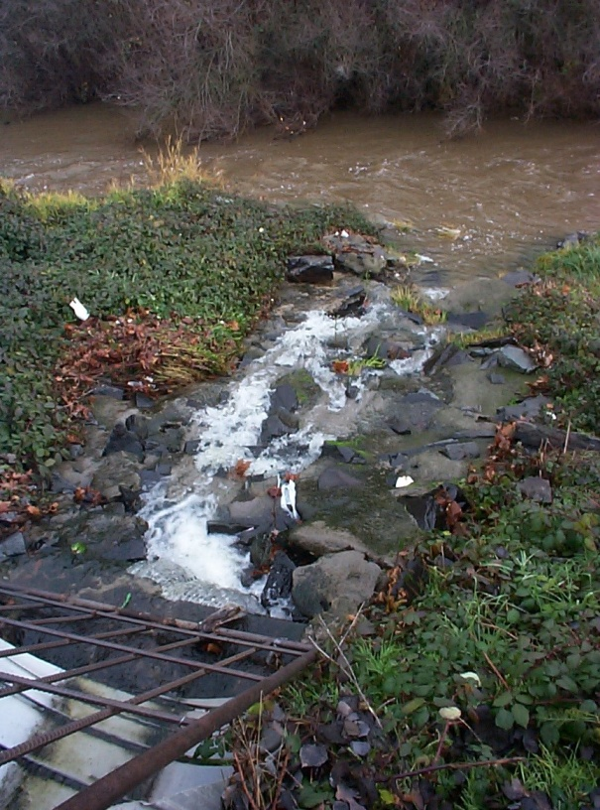
10th (9th) Street over bridge, Medford Riverside and Walnut Street, Medford

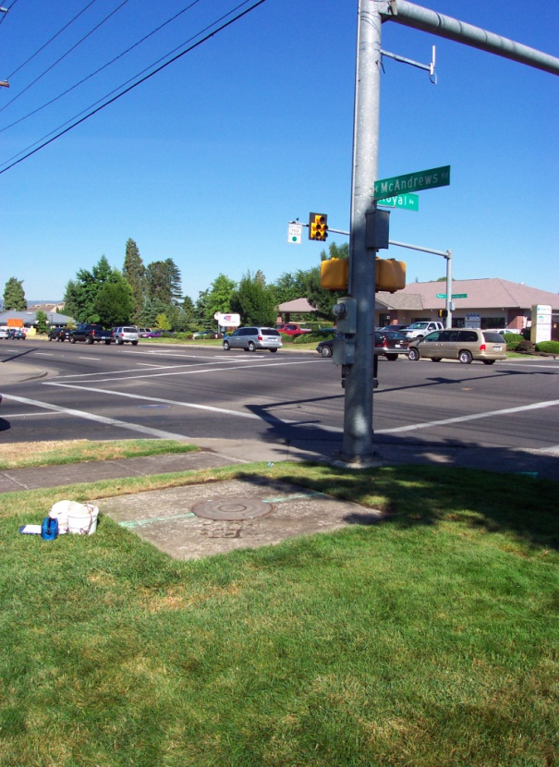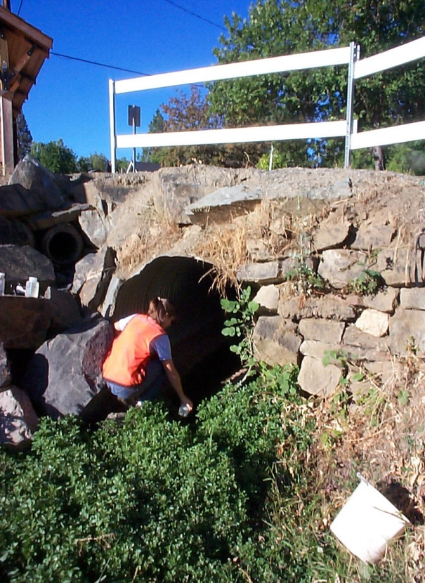
Royal and McAndrews, Medford 4th and Pine, Jacksonville

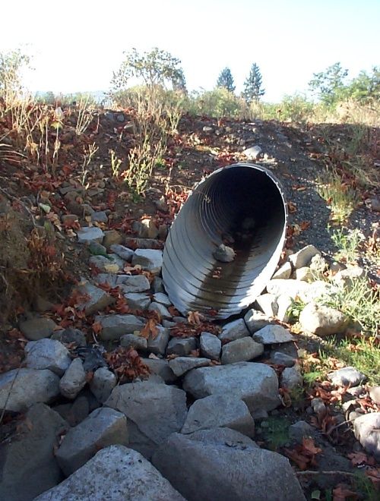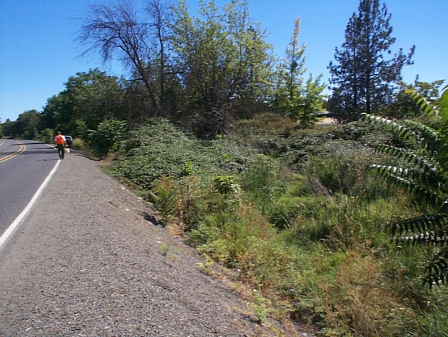
Blackstone Alley, Jacksonville Mingus Creek near Expo Ponds, CP
Mingus Creek

Appendix B: Data Summary by Monitoring Run

Table B-1: Dry Weather All Sites: August 2013 – May 2018
 | Temp (Celsius) | Conductivity | pH | E. coli (MPN) | Phosphorus (mg/L) | BOD (mg/L) | Turbidity (ntus)
Mean | 18.04 | 402.9 | 7.88 | 769.3 | 0.23 | 2.83 | 7.24
Median | 17.95 | 413.9 | 7.87 | 547.5 | 0.18 | 3.06 | 3.35
Max | 22.6 | 641.0 | 8.47 | 2419.2 | 1.05 | 5.66 | 38.1
Min | 12.9 | 109.0 | 6.92 | 0.0 | 0.075 | 0.42 | 0.8
Range | 9.7 | 532.0 | 1.55 | 2419.2 | 0.975 | 5.24 | 37.3

Table B-2: First Flush All Sites: August 2013 – May 2018
 | Temp (Celsius) | Conductivity | pH | E. coli (MPN) | Phosphorus (mg/L) | BOD (mg/L) | Turbidity (ntus)
Mean | 12.6 | 298.3 | 7.62 | 1408.0 | 0.278 | 3.61 | 26.5
Median | 12.0 | 289.5 | 7.58 | 1986.3 | 0.237 | 3.36 | 11.8
Max | 20.1 | 734.0 | 8.78 | 2419.2 | 1.02 | 8.24 | 216.0
Min | 8.2 | 40.2 | 6.64 | 0.0 | 0.054 | 0.10 | 1.0
Range | 11.9 | 693.8 | 2.14 | 2419.2 | 0.967 | 8.14 | 215.0

Table B-3: Wet Weather All Sites: August 2013 – May 2018
 | Temp (Celsius) | Conductivity | pH | E. coli (MPN) | Phosphorus (mg/L) | BOD (mg/L) | Turbidity (ntus)
Mean | 11.3 | 223.2 | 7.55 | 1291.5 | 0.343 | 5.41 | 75.1
Median | 10.4 | 208.1 | 7.54 | 1299.7 | 0.269 | 5.3 | 37.8
Max | 17.9 | 714.0 | 9.65 | 2419.2 | 1.64 | 9.07 | 469.0
Min | 7.7 | 25.8 | 6.19 | 1.0 | 0.075 | 0.14 | 1.1
Range | 10.2 | 688.2 | 3.46 | 2418.2 | 1.565 | 8.93 | 467.9

